1. Create a Flask application with an /api route. When this route is accessed, it should return a JSON list. The data should be stored in a backend file, read from it, and sent as a response.

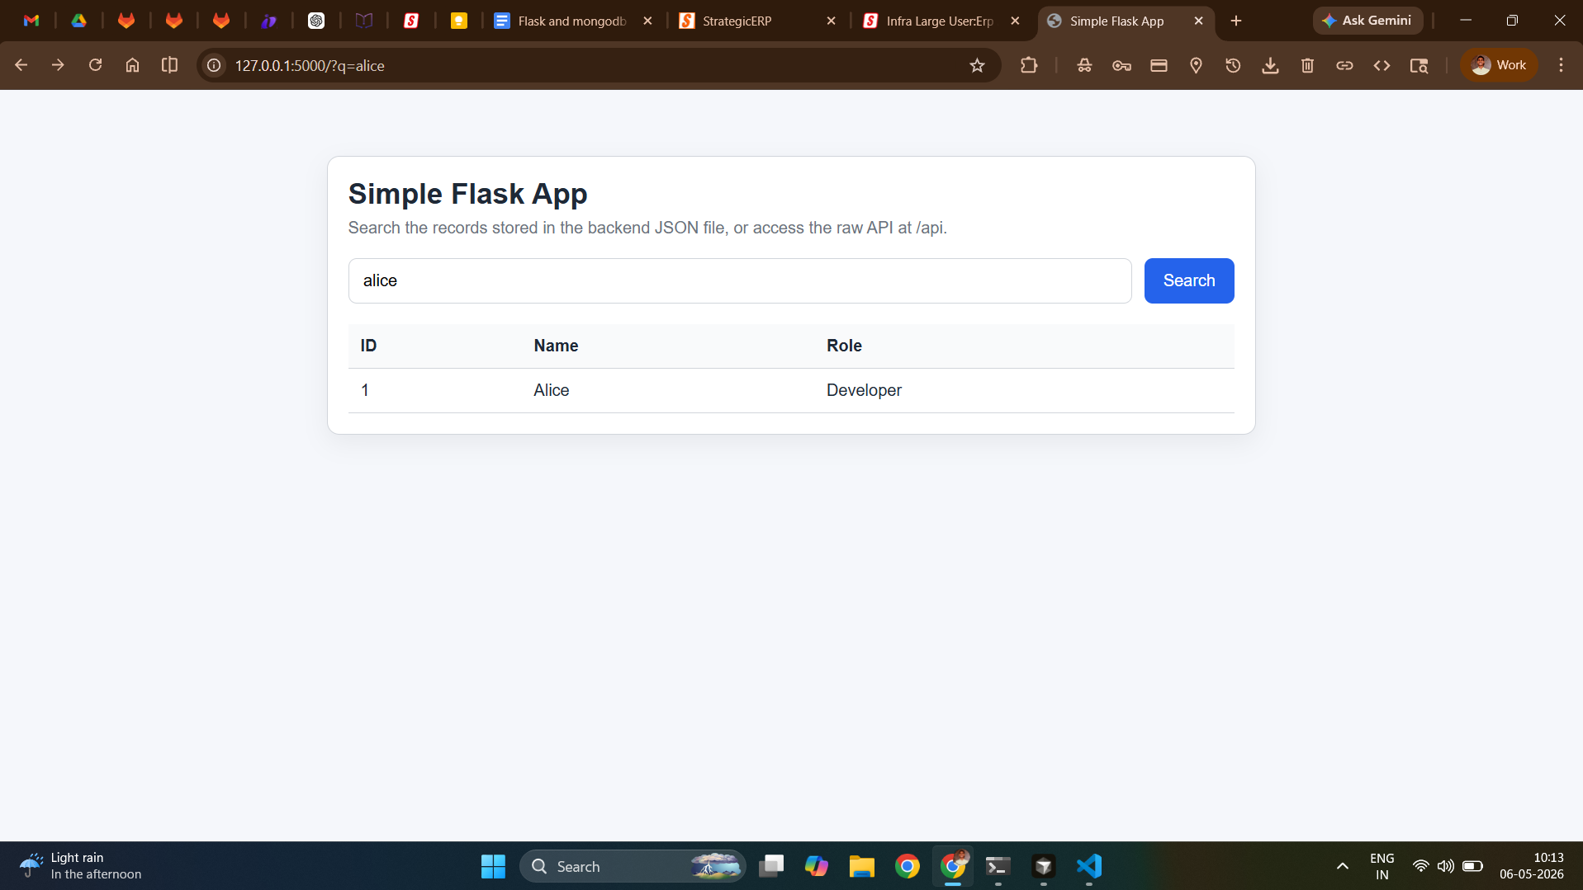
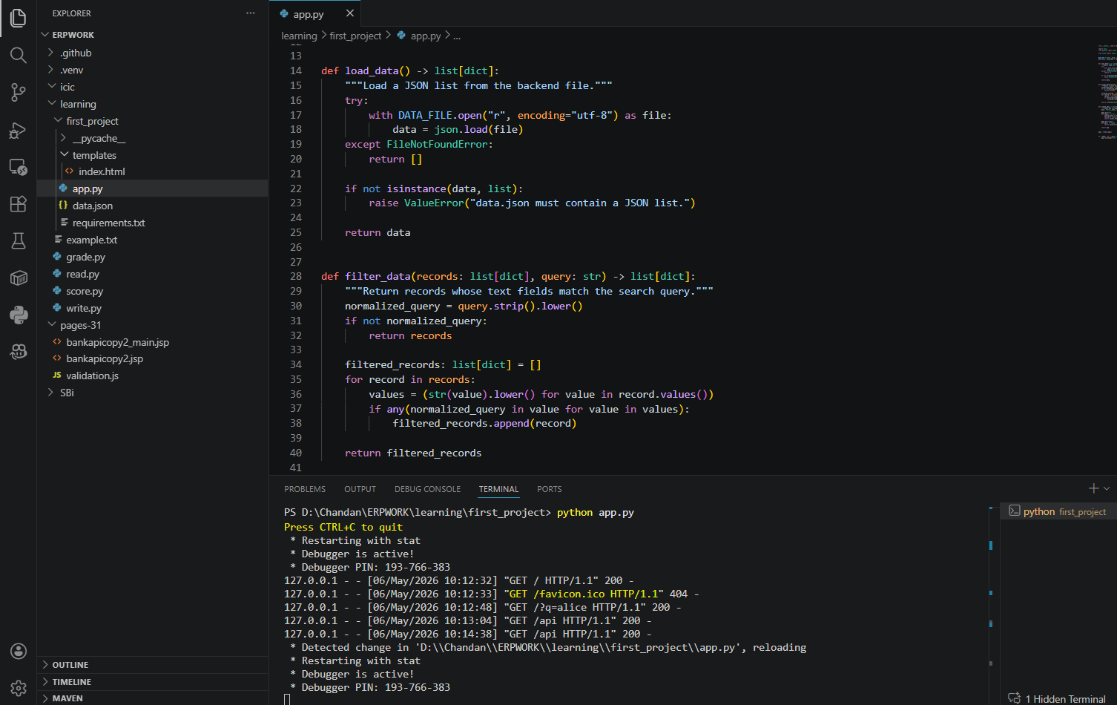
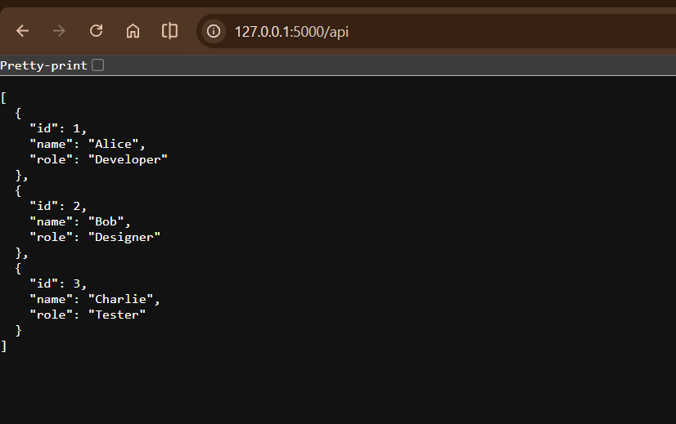

2. Create a form on the frontend that, when submitted, inserts data into MongoDB Atlas. Upon successful submission, the user should be redirected to another page displaying the message "Data submitted successfully". If there's an error during submission, display the error on the same page without redirection.

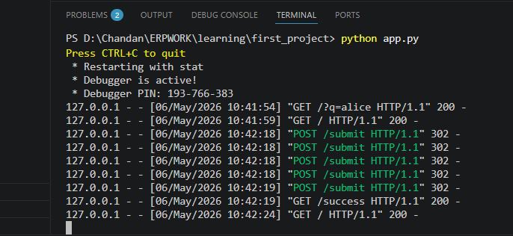
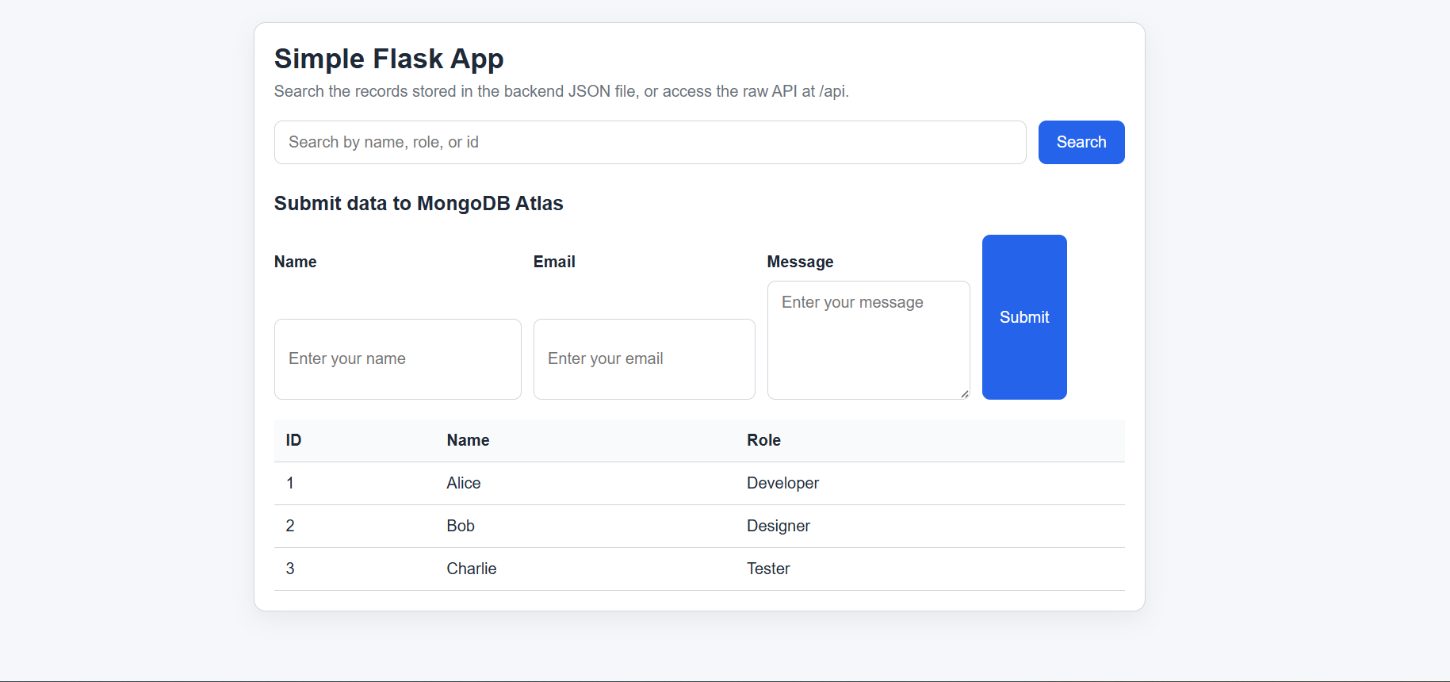
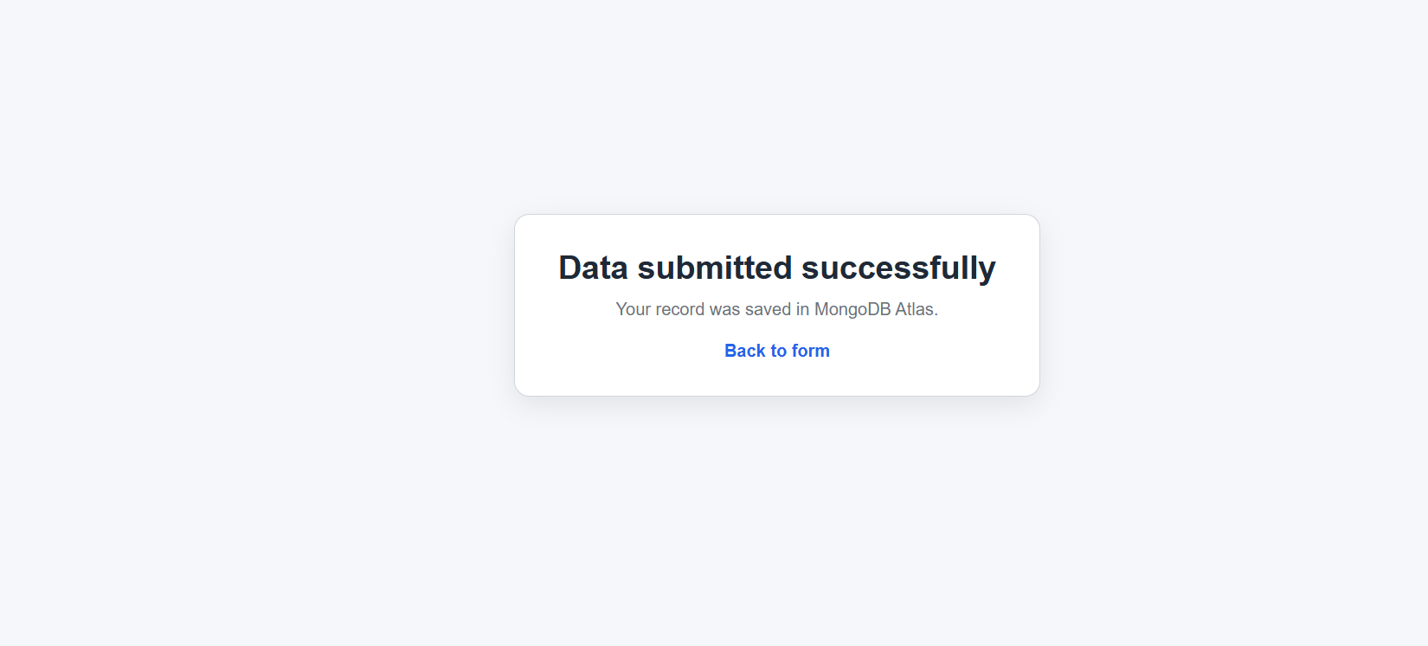
Here's a simple explanation of what we built in `first_project`:
A Flask web application that reads data from a JSON file and allows users to submit new data to MongoDB Atlas.

**What it does:**
1. **Homepage (`/`)** — Shows a simple page with:
- A search box to filter and display existing records from `data.json`
- A form with fields: Name, Email, Message
- A table showing all matching records
2. **MongoDB Form Submit (`POST /submit`)** — When you fill the form and click Submit:
- The app sends your name, email, and message to MongoDB Atlas
- If successful → redirects to a success page
- If there's an error (missing fields, MongoDB down, wrong credentials) → shows the error on the same page

3. **Success Page (`/success`)** — Shows "Data submitted successfully" and a link back to the form

4. **JSON API (`/api`)** — Returns all data from `data.json` as JSON

**The files:**
- app.py — The Flask application (routes and logic)
- `data.json` — Local file with initial example records
- `templates/index.html` — The main search and form page
- `templates/success.html` — The success confirmation page
- .env — Your MongoDB Atlas connection string (kept private)
- `requirements.txt` — List of Python packages needed

Submission Guidelines -: Attach Screenshots or command along with explanation and submit in doc(google doc or micro

